Cybersecurity Framework for Small Businesses
(Practical Implementation Report)

Spinnaker Analytics

Table of Contents

Abstract
Introduction
System Requirements
Firewall Configuration
Vulnerability Scanning (OpenVAS)
DoS Attack Simulation (hping3)
Results
Advantages
Limitations
Conclusion
Future Enhancements

Abstract

This project presents a practical implementation of a cybersecurity framework designed for small businesses using open-source tools on Kali Linux. The framework focuses on identifying vulnerabilities, securing network infrastructure, and protecting systems from cyber threats such as DoS/DDoS attacks, brute force attacks, and malware. A hands-on approach is followed using tools like Nmap, iptables, Fail2Ban, Snort, OpenVAS, and ClamAV. The project also demonstrates real-time attack simulation and mitigation techniques.

1. Introduction

Small businesses often lack proper cybersecurity infrastructure, making them vulnerable to attacks. This project aims to implement a lightweight and cost-effective cybersecurity solution using Kali Linux and open-source tools. The framework is aligned with industry standards and includes real-time monitoring, prevention, and recovery mechanisms.

2. System Requirements
Hardware
Minimum 8GB RAM
40GB free disk space
Software
Kali Linux (Primary system)
VirtualBox / VMware (Optional)
Target Machine (Ubuntu/Windows)
Methodology (Step-by-Step Implementation)

Step 1: System Update
The system was updated to ensure all tools and packages are current.
sudo apt update && sudo apt upgrade -y

Step 2: Network Identification
The IP address of the system was identified using:
ip a
This IP was used as the target for scanning and testing.

Step 3: Network Scanning (Nmap)
Nmap was used to identify open ports and running services.
sudo apt install nmap -y
nmap -sV 192.168.x.x
Outcome:
- Detected active services
- Identified potential vulnerabilities
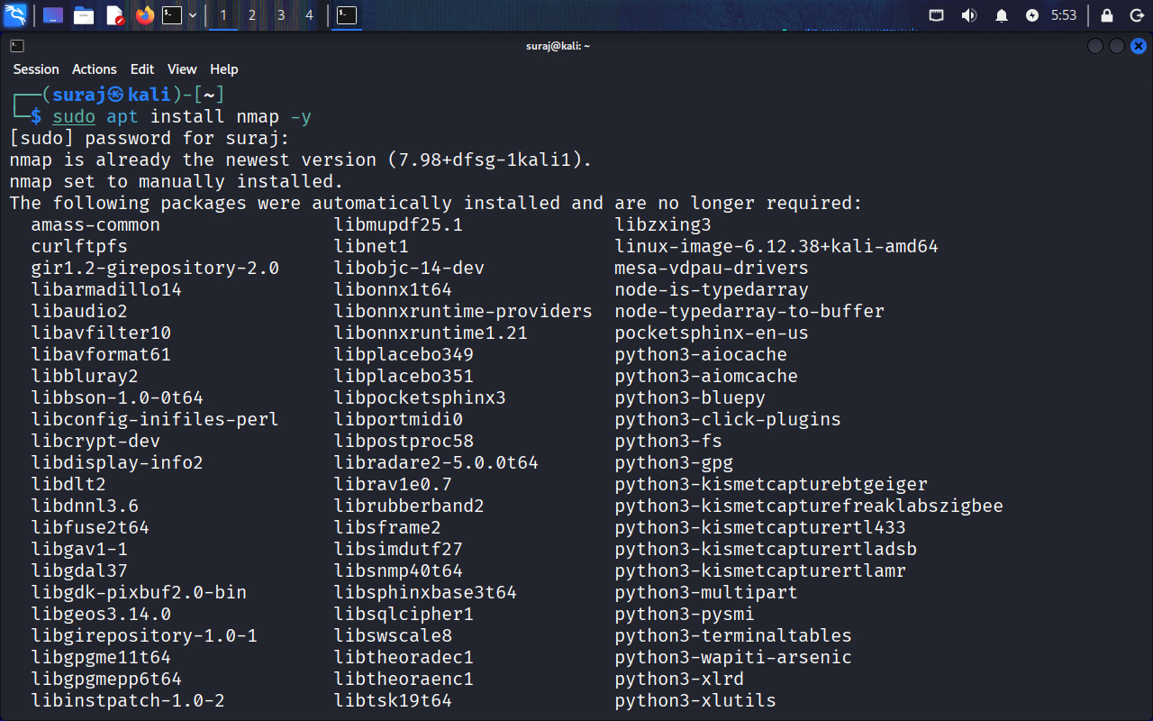
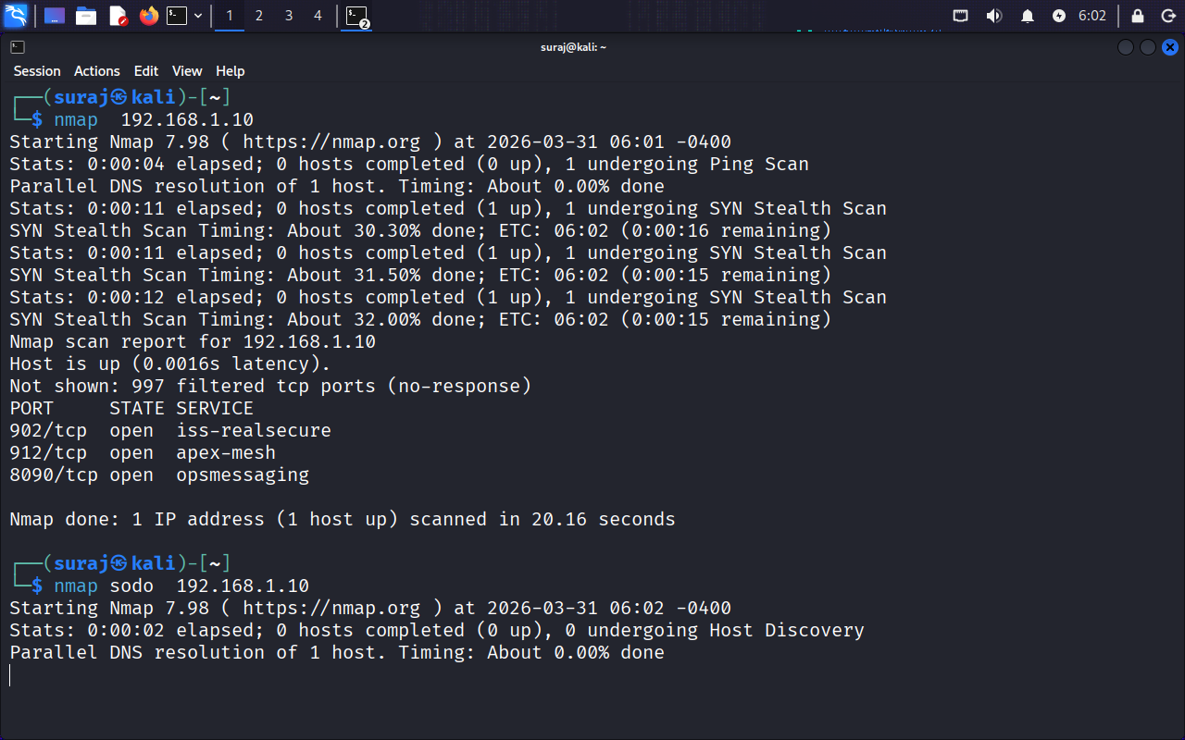
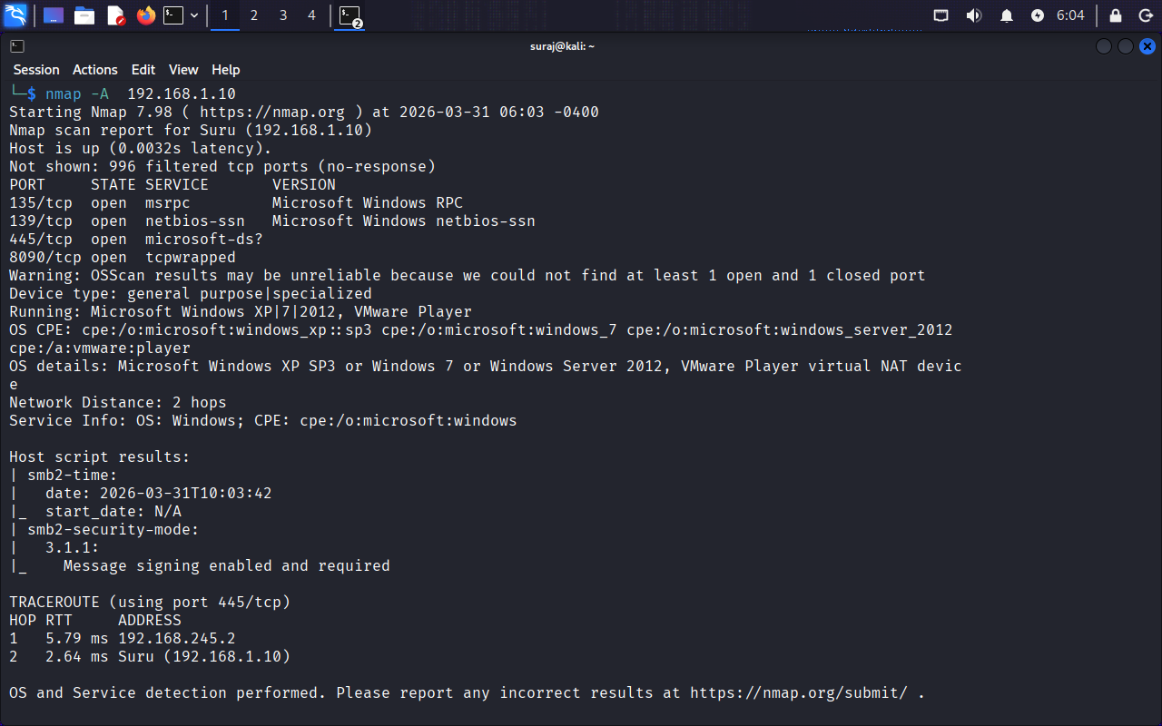

Step 4: Firewall Configuration (iptables)
Rules Implemented:
Allow established connections
sudo iptables -A INPUT -m conntrack --ctstate ESTABLISHED,RELATED -j ACCEPT
Prevent SYN Flood (DoS attack)
sudo iptables -A INPUT -p tcp --syn -m limit --limit 1/s -j ACCEPT
sudo iptables -A INPUT -p tcp --syn -j DROP
Prevent Ping Flood
sudo iptables -A INPUT -p icmp -m limit --limit 1/s -j ACCEPT
sudo iptables -A INPUT -p icmp -j DROP

Save rules

sudo apt install iptables-persistent
sudo netfilter-persistent save
Step 5: Brute Force Protection (Fail2Ban)
sudo apt install fail2ban -y
sudo systemctl enable fail2ban
sudo systemctl start fail2ban
sudo systemctl status fail2ban
Outcome:
Automatically blocks repeated failed login attempts
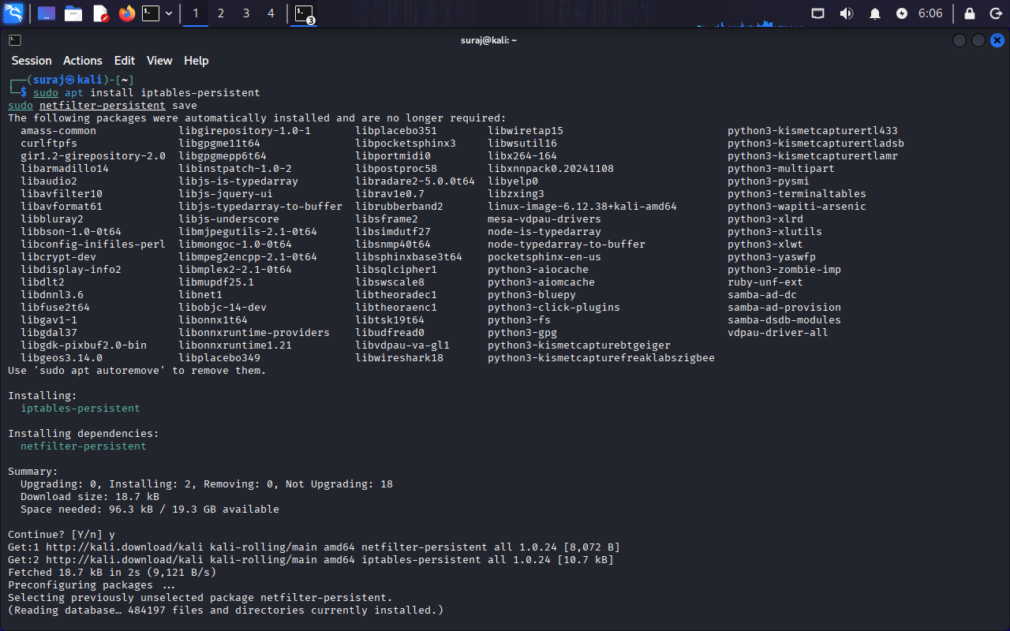

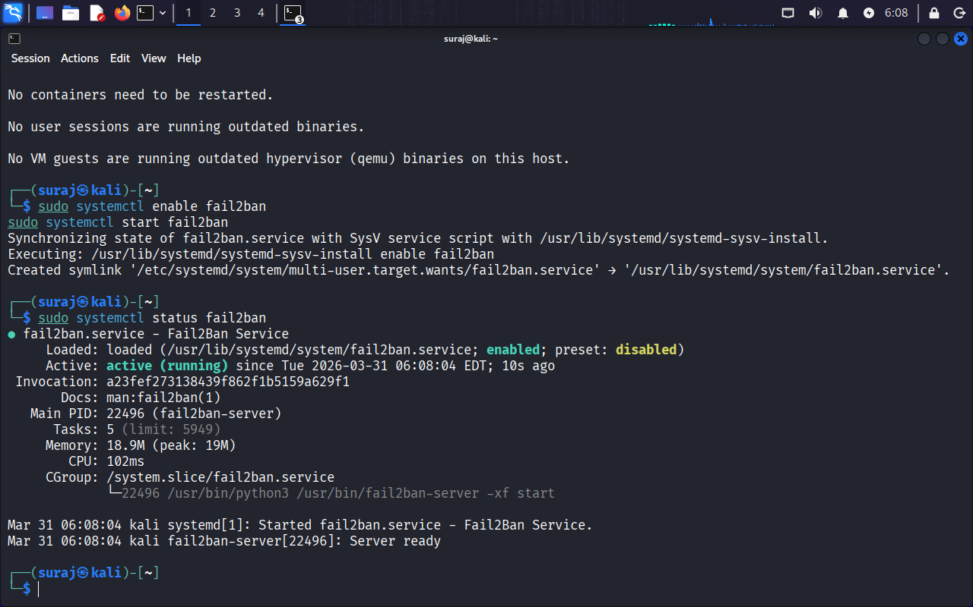
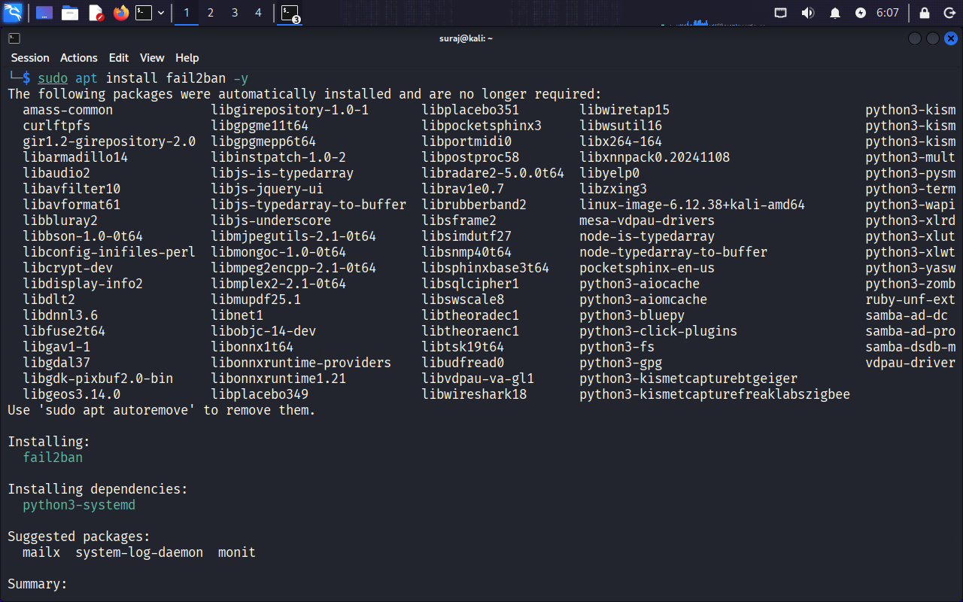

Step 6: Intrusion Detection System (Snort)
sudo apt install snort -y
Configured with local network range
Monitors suspicious traffic
Step 7: Vulnerability Scanning (OpenVAS)
sudo apt install openvas -y
sudo gvm-setup
sudo gvm-start
Access:
https://127.0.0.1:9392
Outcome:

- Identified system vulnerabilities
- Generated security reports

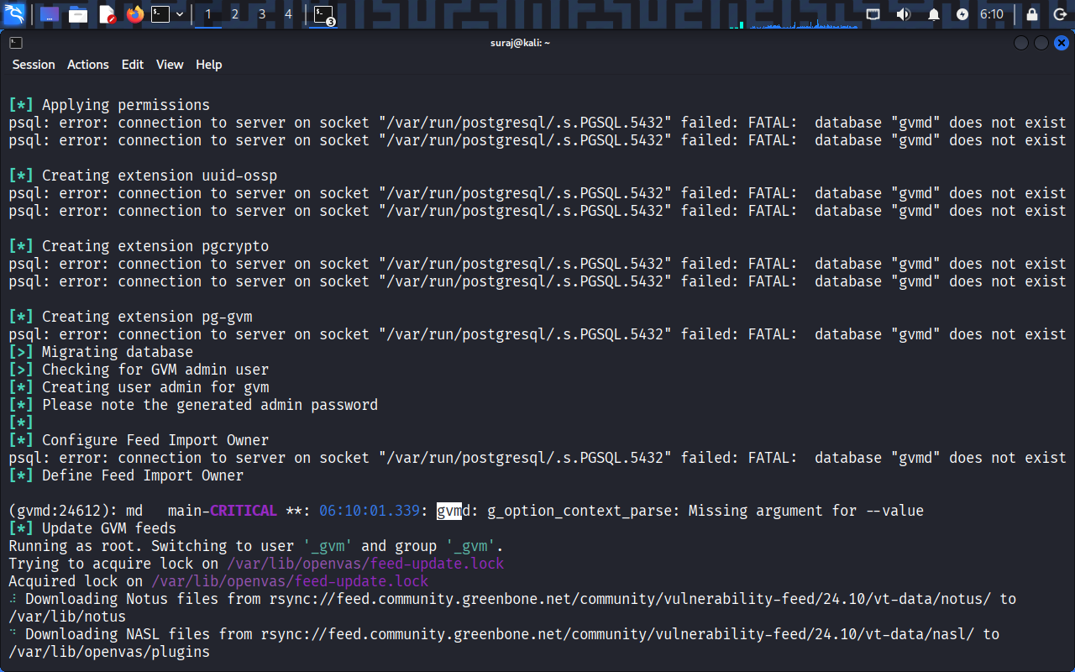

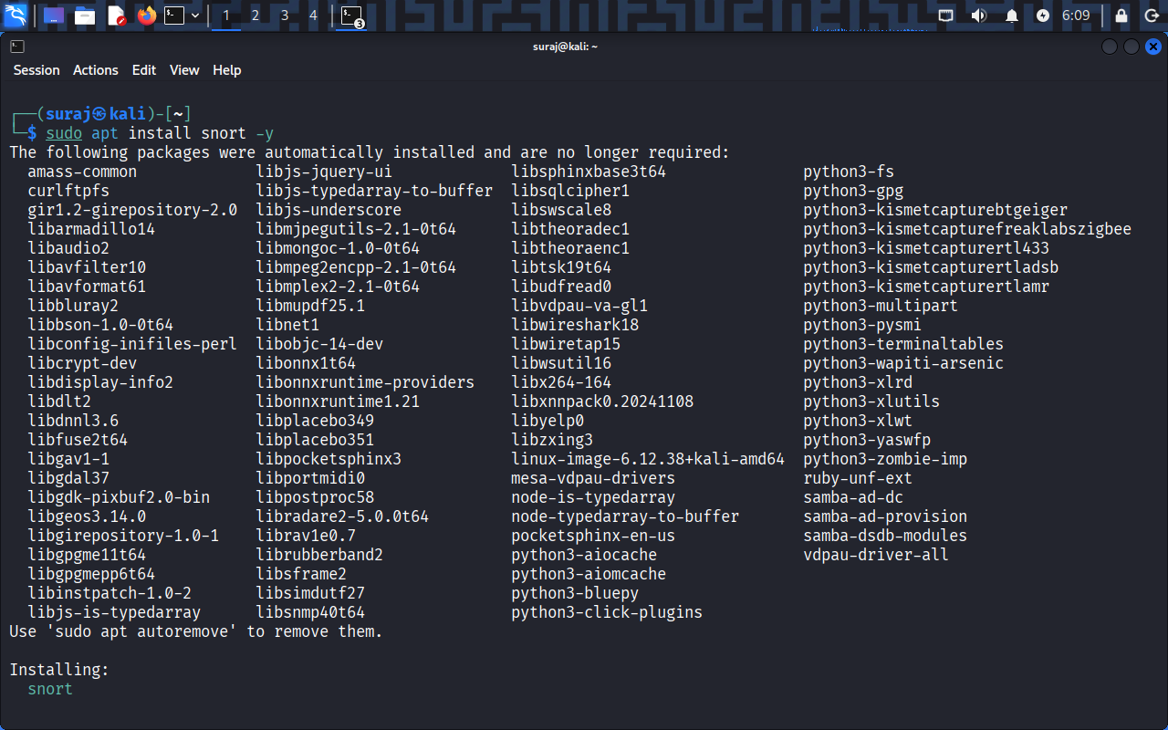

Endpoint Security (ClamAV)
sudo apt install clamav -y
sudo freshclam
clamscan -r /home
Outcome:
Malware detection and removal

Step 9: Data Protection
Encrypt file
gpg -c test.txt
Restrict access
chmod 600 test.txt
Backup data
rsync -av /home /backup

Step 10: DoS Attack Simulation (hping3)
sudo apt install hping3 -y
hping3 -S --flood 192.168.x.x

Testing Results:

Before firewall → System performance degraded
After firewall → Attack mitigated successfully
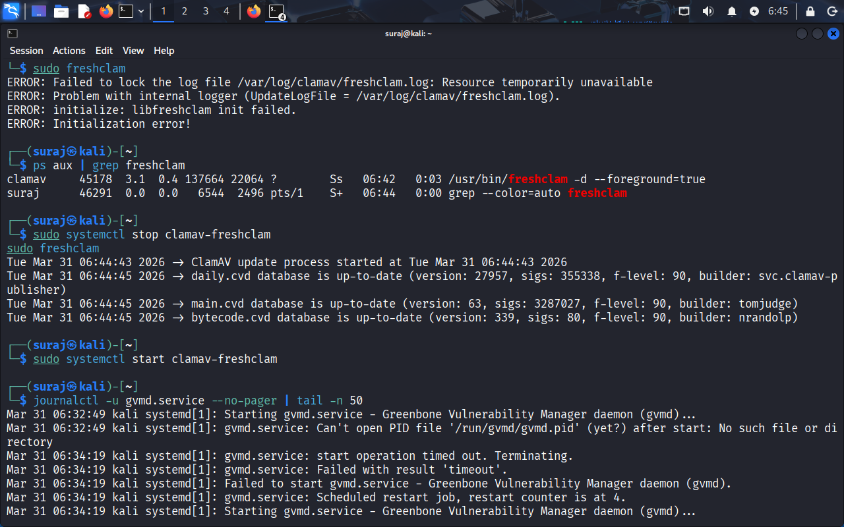
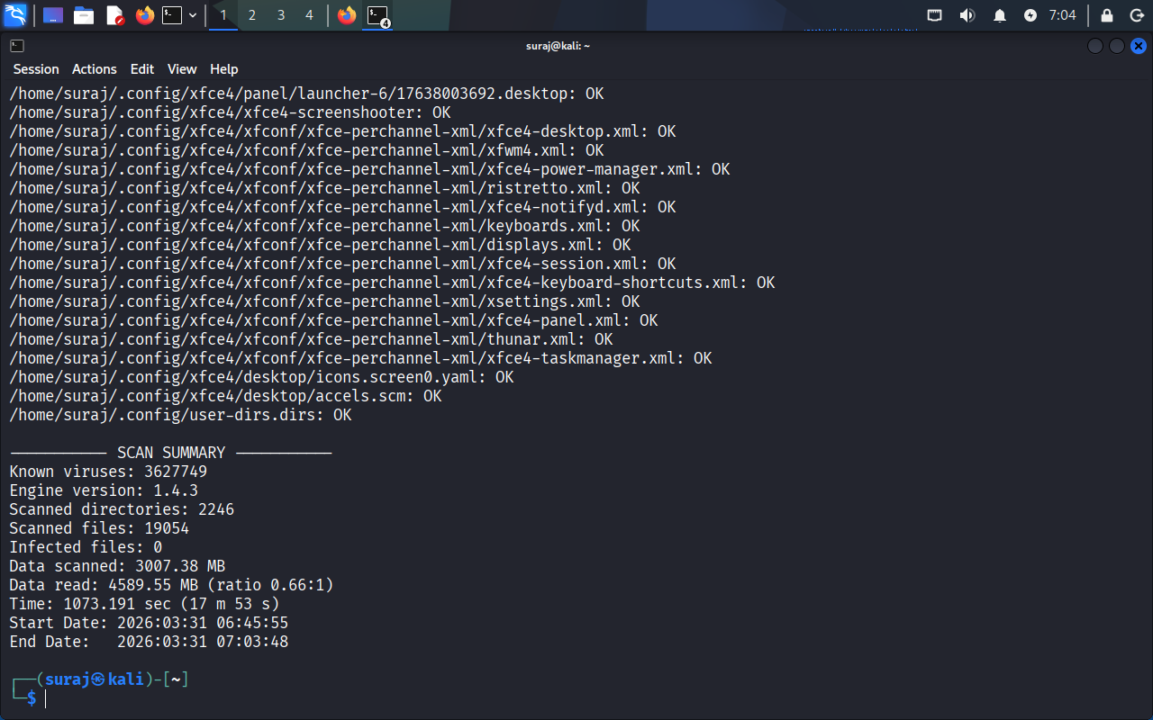

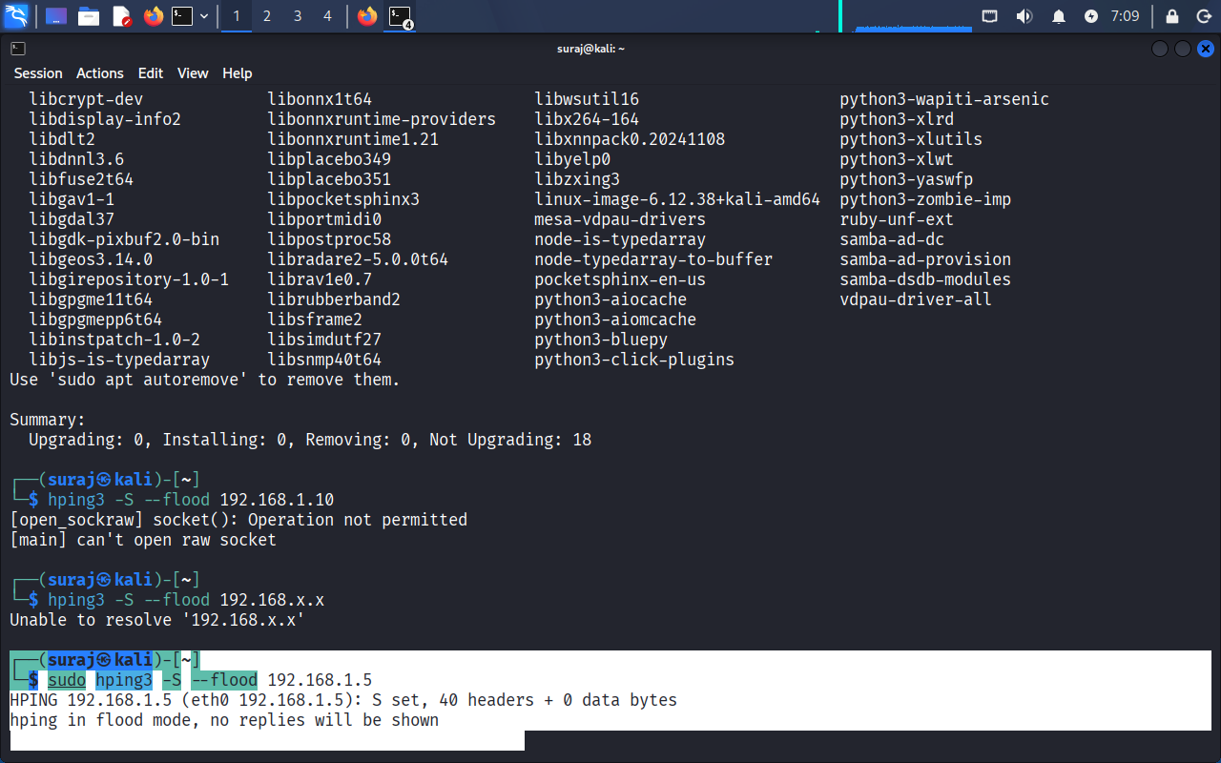
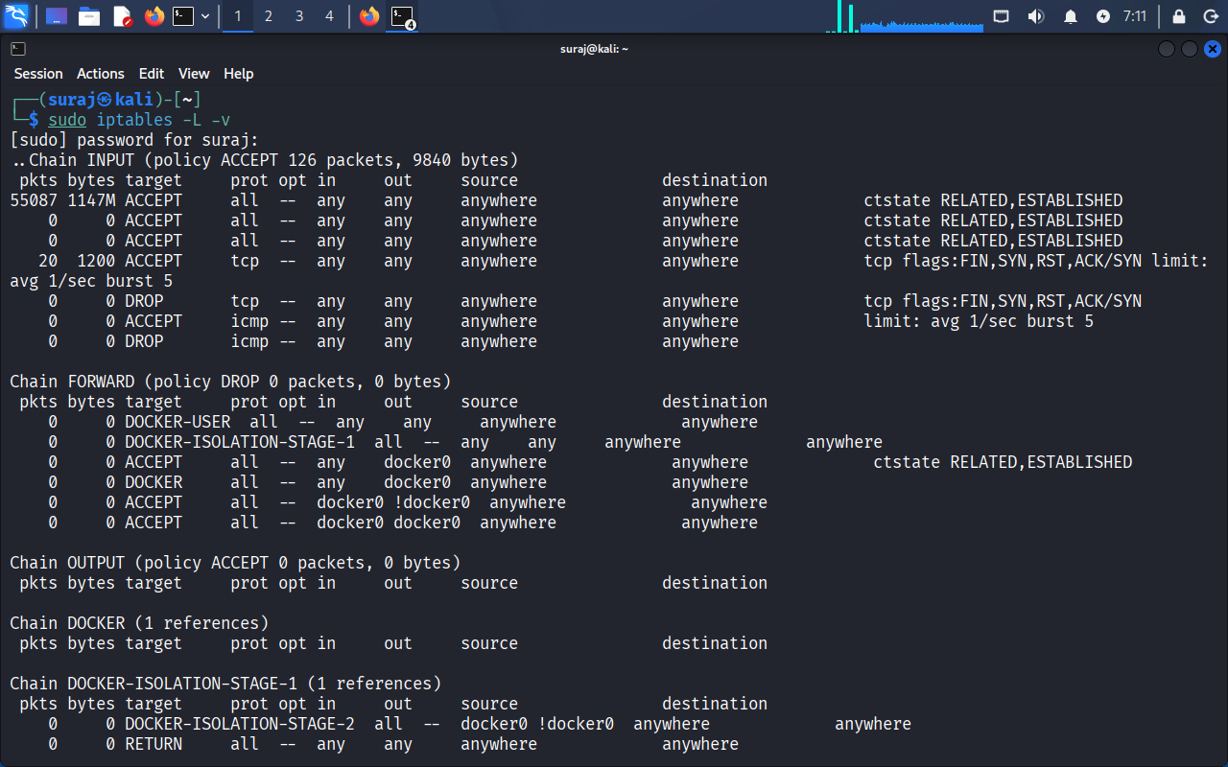
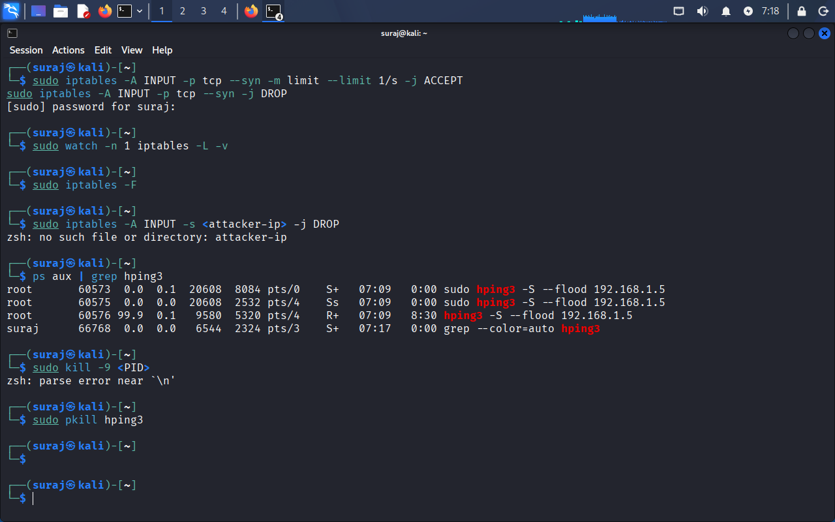

4. Framework Mapping (NIST Cybersecurity Framework)
- Function Implementation
- Identify Nmap scanning
- Protect Firewall (iptables), ClamAV
- Detect Snort IDS
- Respond Fail2Ban
- Recover Backup using rsync
Results
- Successfully identified vulnerabilities
- Implemented firewall rules to prevent DoS attacks
- Blocked brute-force login attempts
- Detected threats using IDS
- Secured data through encryption and backups
Advantages
- Fully open-source and cost-effective
- Hands-on practical implementation
- Easy to replicate
- Scalable for small businesses

Limitations
- Requires technical knowledge
- Manual configuration needed
- Limited automation
Conclusion
- The project successfully demonstrates a practical cybersecurity framework using open-source tools. It provides effective protection against common cyber threats and ensures system security through continuous monitoring, detection, and response mechanisms.

Future Enhancements
- Automate security monitoring
- Integrate SIEM tools
- Add cloud security features
- AI-based threat detection

